**A PROJECT SYNOPSIS**

**on**

**AR SMART NEWSPAPER**

**Submitted By**

1. **SHUBHAM PATIL (58)**
2. **BHAVESH PATIL (55)**
3. **DHIRAJ NAIK (48)**

**Under the Guidance of**

Prof. Vrushali Thakur

**Department of Information Technology**



Saraswati Education Society’s

**SARASWATI COLLEGE OF ENGINEERING**

Kharghar,Navi Mumbai

(Affiliated to University of Mumbai)

Academic Year :-2020-21

**Saraswati College of Engineering, Kharghar**

**Vision:**

To become center of excellence in Engineering education and research.

**Mission:**

To educate students to become quality technocrats for taking up challenges in all facets of life.

**Department of Information Technology**

**Vision:**

To create technically qualified talent through research to take up challenges in industries.

**Mission:**

1. To impart quality education.

2. To develop technical and managerial skills through training and modern teaching-learning process.



**(Approved by AICTE, reg. By MaharashtraGovt. DTE,Affiliated to Mumbai University)**

**PLOT NO. 46/46A, SECTOR NO 5, BEHIND MSEB SUBSTATION, KHARGHAR,NAVI MUMBAI-410210**

**Tel. : 022-27743706 to 11 * Fax : 022-27743712 * Website: www.sce.edu.in**

**CERTIFICATE**

*This is to certify that the requirements for the synopsis entitled “AR SMART NEWSPAPER”*

*Have been successfully completed by the following students:*

Roll numbers Name

58 SHUBHAM PATIL

55 BHAVESH PATIL

48 DHIRAJ NAIK

In partial fulfillment of Sem –VI **Bachelor of Engineering of Mumbai University in Information Technology** of Saraswati college of Engineering, Kharghar during the academic year 2020-21.

**Internal Guide**  **External Examiner**

Prof. Vrushali Thakur

**Project coordinator Head of Department**

Prof. Vrushali ThakurProf. Diksha G Kumar

**Acknowledgement**

A project is something that could not have been materialized without cooperation of many people. This project shall be incomplete if I do not convey my heartfelt gratitude to those people from whom I have got considerable support and encouragement.

It is a matter of great pleasure for us to have a respected **Prof. Vrushali Thakur** as my project guide. We are thankful to her for being constant source of inspiration.

We would also like to give our sincere thanks to **Prof. Diksha G Kumar, H.O.D, Information Technology** Department**, Prof. Vrushali Thakur**, **Project co-ordinator** for their kind support.

We would like to express our deepest gratitude to **Dr. Manjusha Deshmukh,**our principal of Saraswati college of Engineering, Kharghar, Navi Mumbai

Last but not the least I would also like to thank all the staffs of Saraswati college of Engineering (Information Technology Department) for their valuable guidance with their interest and valuable suggestions brightened us.

1. **SHUBHAM PATIL (58)**
2. **BHAVESH PATIL (55)**
3. **DHIRAJ NAIK (48)**

**INDEX**

**1. Introduction**

**2. Literature survey**

**3. Comparative Analysis**

**4. Problem statement**

**5. Details of Hardware and Software**

**6. Conclusion**

**7. References**

**1.Introduction**

Printed materials from magazines to papers and even books had suffered a reduction of appealing with the arrival of the digital world. Digital news are up-to-the-second, often free and with the reach of the pocket.AR technology experts have broken the traditional approach for publishers with the introduction of a seamless experience between the screen and the printed page. AR technology creates models from content that take a brand new experience to readers of any age to the next level. Whether in the case magazine cover or storytelling AR is incredibly exhilarating the experience with digital and emerging technology. the digital stunning experience with dynamic 3D models, interactive objects, videos and images. Brining up-to-the-second updates flavor to your reading.

AR is a technology that amalgamates virtual information onto the real surrounding. It includes the use of multimedia,3D modelling sensing, intelligent interaction, real time tracking and response system and much more. The basic principle is to put in computer generated information, which is virtual, such as 3d images, text, videos, movies to the real surroundings after creating simulation. The different information and data complement each other and, in the process, achieve and enhanced real world. In this research paper, we are implementing an app in which we will be having an interactive newspaper with interactive images. The newspapers will contain live images that will add extra det ail and colour to live and adapt. We will be using latest feature of ARK it to turn our newspaper into a magical newspaper that will play the content that is relevant to the image that is being detected (Apple Inc, 2020). It will turn a boring and standard newspaper into something that is extremely interesting and it revamps the experience of reading newspaper.

**Paper 1-** An augmented reality image registration method based on improved ORB

**Year of publication** -2017

**Author-**Taneja, K., & Bhatia, S.

**Methodology;**

In the process of Augmented Reality (AR) image registration, the traditional ORB (oriented FAST and rotated BRIEF) algorithm has low registration rate and poor real-time performance. In this paper, an improved AR image registration method based on improved ORB is proposed. Firstly, the calibration image and video frame image feature points are obtained by the improved FAST feature detection algorithm. Then, the binary descriptor of BRISK, which using the custom domain sampling pattern is used for feature description, and the scale invariance of the traditional ORB algorithm is improved. Finally, the random sampling consistency (RANSAC) algorithm is used to eliminate the wrong matching point pairs and optimize the feature matching. Experiments show that compared with the AR image registration method described by the traditional ORB algorithm and the FREAK feature, the registration rate of the proposed algorithm is increased by 1.1% and 8.4%, and the generation time is reduced by 0.13s and 0.12s, respectively. The experimental results show that the AR image registration method proposed in this paper can obtain higher feature point registration rate, and has better real-time performance, which can better meet the application needs of AR image registration

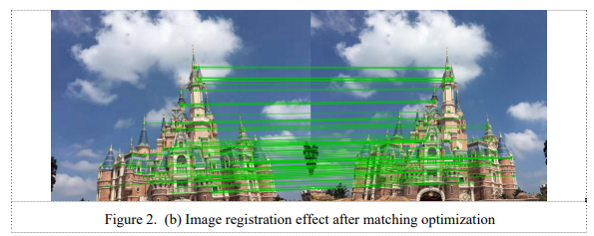

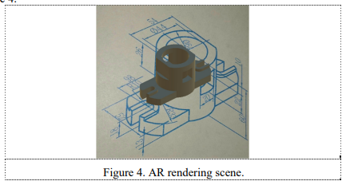

**Paper 2-** Augmented Reality Application for Newspapers

**Year of publication** -2021

**Author-**Ihtiram Raza Khan, Anuj Goyal, Mehtab Alam

**Methodology;**

In this research paper, they are implementing an app in which we will be having an interactive newspaper with interactive images. The newspapers will contain live images that will add extra detail and colour to live and adapt. They will be using latest feature of ARKit to turn our newspaper into a magical newspaper that will play the content that is relevant to the image that is being detected (Apple Inc. 2020).

It is basically a way of implementing augmented reality and pretty similar to other framework that implement augmented reality. Currently one of the most popular framework for implementing AR reality, specially when we are working with unity. Apple AR kit work in a similar way in essence that allows us to create and track correspondence between the real world space, 3D space and the virtual space that we create a model of some visual content.

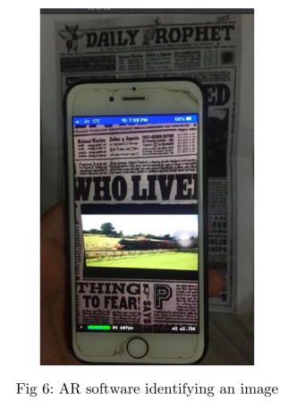

**Paper 3-** Examining augmented reality in journalism: Presence, knowledge gain, and perceived visual authenticity

**Year of publication** -2018

**Author-** Tanja Aitamurto, Laura Aymerich-Franch, Jorge Saldivar, Catherine Kircos, Yasamin Sadeghi, Sukolsak Sakshuwong

**Methodology;**

Visuals in news articles serve journalism’s claim to provide a truthful depiction of the world. Photorealistic visuals are used in news to support the journalistic norms of accuracy and authenticity. According to these aspirational norms, visual journalism should depict events in a comprehensive, realistic, and truthful manner. These norms provide a foundation for journalism’s role as a truth-teller in society. By claiming to operate within these normative boundaries, journalism differentiates itself from other communication practices, such as advertising and propaganda. With its immersive features and 3D renderings of objects, AR has the potential to contribute to the perceived accuracy, authenticity, and credibility of visuals, similar to video and multimedia. This, in turn, can increase the perceived credibility of news reporting. Perceived realism and sense of presence in VR have been shown to have a positive association.

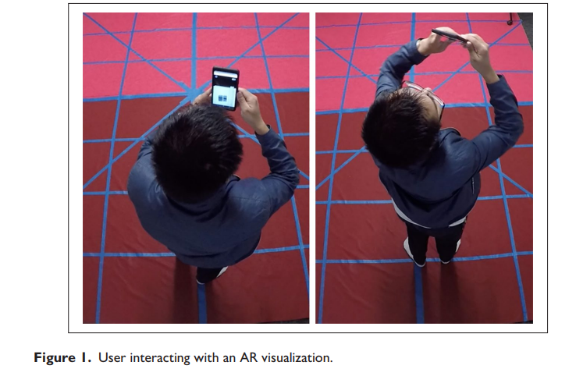

**Paper 4-** Augmented Reality Dynamic Image Recognition Technology Based on Deep Learning Algorithm

**Year of publication** -2019

**Author-** Qiuyun Cheng , Sen Zhang, Shukui Bo , Dengxi Chen , Haijun Zhang

**Methodology;**

This paper combines a convolutional neural network that can learn good feature information with integrated learning that has good recognition effects. In the recognition tasks of the MNIST database and the CIFAR-10 database, comparison experiments were performed by adjusting the hierarchical structure, activation function, descent algorithm, data enhancement, pooling selection, and number of feature maps of the improved convolutional neural network. The convolutional neural network uses a pooling size of 3*3, and uses more cores (above 64), small receptive fields (2*2), and more hierarchical structures. In addition, the Relu activation function, gradient descent algorithm with momentum, and enhanced data set are also used. The research results show that under certain experimental conditions, the dynamic image recognition results have dropped to a very low error rate in the MNIST database, and the error rate in the CIFAR-10 database is also ideal.

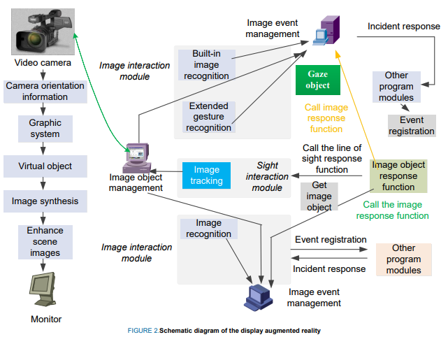

**Paper 5-** Capabilities of ARCore and ARKit Platforms for AR/VR Applications

**Year of publication** -2019

**Author-** Paweł Nowacki and Marek Woda

**Methodology;**

In this paper ARCore and ARkit capabilities were scrutinized and compared. Authors established comparison criteria for both platforms, developed test applications and ran comparison tests. Obtained results can be a help in choosing the right framework to speed up prototyping and development of modern AR/VR applications. This work consists of a comprehensive comparison of these new frameworks in the following respects: general performance (CPU/memory use), mapping of planes on various surface types, influence of light and movement on mapping quality etc.

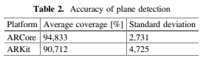

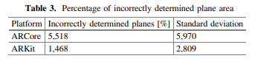

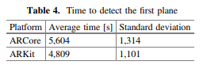

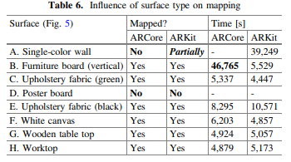

**3. Comparative Analysis**

|  |  |  |  |  |  |
| --- | --- | --- | --- | --- | --- |
| Papers  Parameter | An augmented reality image registration method based on improved ORB | Augmented Reality Application for Newspapers | Examining augmented reality in journalism: Presence, knowledge gain, and perceived visual authenticity | Augmented Reality Dynamic Image Recognition Technology Based on Deep Learning Algorithm | Capabilities of ARCore and ARKit Platforms for AR/VR Applications |
| AR Used | Yes | Yes | Yes | Yes | Yes |
| ARCore Used | No | No | No | No | Yes |
| ARKit  Used | No | Yes | No | No | Yes |
| Deep Learning Used | No | No | No | Yes | No |
| ORB used | Yes | No | No | No | No |
| Android App | No | Yes | No | No | No |

**4. Problem Statement**

Interactive learning allows the user to participate and interact with in the learning environment. However, due to the enhancement of learning environment, the conventional way of learning docs not satisfy the people and the learning activity started to feel bored and nostalgic.

It is because the interaction between the learning tools and the user is limited to static stuffs such as text. It seems hard for students to visualize and they will fail to focus. On the task in hand. Augmented Reality is a term for a live direct or an indirect view of a physical, real-world environment. Learning using Augmented Reality enhances the view and experience of learning as well as the learner.

The learning interactive application using Augmented Reality concept will add in multimedia elements such as pictures, graphics, sounds, animations, etc. It is used to enrich the learning environment and to let the users get fully involved in the learning activity. The augmented reality systems works in a manner that when the user moves around, he can sec the virtual objects and the animations being projected around him.

The newspapers want to attract new audiences especially young people to increase, they want number of readers.

**5. Detail of Hardware and Software**

**5.1Hardware Requirements –**

* ∙ Android / IOS Smartphone
* ∙ I3+ Processor System
* Sensors like Accelerometer, Gyroscope, Magnetometer
* Camera

**5.2 Software Requirement-**

* Vuphoria
* ARkit
* ARcore
* Android Studio
* Xcode

**6. Conclusion –**

For future developments it can be enhanced by developing this system for big newspapers or magzines. At the same time, the launch of ARKit and ARCore development platforms realises the combination of augmented reality and smart mobile devices technically. In the future development, smart newspapers, which can give full play to the advantages of augmented reality technology, will create a more realistic integration world for human beings. People can interact with the system in a more natural way of human-computer interaction. In the future, augmented reality technology will change human life to a great extent, which is an inevitable trend of scientific and technological development.

**7. Reference-**

* An augmented reality image registration method based on improved ORB - Mingzhi Cheng, Luyue Zhang, Long LiuSeed Sowing arduino. (2019).
* Augmented Reality Application for Newspapers - Ihtiram Raza Khan, Anuj Goyal, Mehtab Alam
* Examining augmented reality in journalism: Presence, knowledge gain, and perceived visual authenticity

- Tanja Aitamurto, Laura Aymerich-Franch, Jorge Saldivar, Catherine Kircos, Yasamin Sadeghi, Sukolsak Sakshuwong Multi-Agent Planning for Coordinated  Robotic Weed Killing(2018)

* Augmented Reality Dynamic Image Recognition Technology Based on Deep Learning Algorithm - Author: Qiuyun Cheng , Sen Zhang, Shukui Bo , Dengxi Chen , Haijun Zhang
* <https://developers.google.com/ar/develop/java/quickstart>
* <https://www.journaldev.com/21479/android-augmented-reality-arcore-example>
* <https://code.tutsplus.com/tutorials/android-sdk-augmented-reality-camera-sensor-setup--mobile-7873>
* <https://library.vuforia.com>

∙

**Program Educational Objectives (PEO)**

1. To prepare the candidate for a successful career in the industry and make him acquainted with the latest software and hardware,

2. To enable student to work productively as computer engineers, including supportive teamwork and leadership roles on multidisciplinary teams,

3. Graduates are prepared to be responsible computing professionals in their own area of interest, 4. To provide the candidate with a sound foundation in mathematics, software technologies, database technologies, networking, hardware and to prepare them for post graduate studies and research programs.

5. To promote the awareness of lifelong learning among students and to introduce them to professional ethics and codes of professional practice,

6. To demonstrate effective communication skills in oral, written and electronic media.

**Program Outcomes (PO)**

At the end of the program, a student will be able to:

1. Apply knowledge of mathematics, science and engineering.

2. Utilize the computer engineering knowledge in all domains, viz., health care, banking and Finance, other professions such as medical, law, etc.

3. Design and conduct experiments as well as to analyze and interpret data.

4. Analyze the problem, subdivide it into smaller tasks with well-defined interface for interaction among components, and complete the task within the specified time frame and financial constraints,

5. Design a system, component or process to meet the desired needs within realistic constraints such as economic, environmental, social, political and Ethical ability,

6. Design, implement, and evaluate secure hardware and/or software systems with assured quality and efficiency,

7. Communicate effectively the engineering solution to customers/users or peers,

8. Understand professional and ethical responsibilities,

9. Understand contemporary issues and to get engaged in lifelong learning by independently and continually expanding knowledge and abilities,

10. Function in multidisciplinary teams,

11. Identify, formulate and solve engineering problems.

**Course Objective and Scope:**

1. To understand the problem and to design and implement solution.

2. Gain project management skills

3. Understand current tools and market trends

4. Develop the management and team management skills

5. Acquire presentation skills.

**Expected Outcomes:**

1. Ability to critically analyze a problem and to design implement and evaluate a computing solution

that meets requirement.

2. An ability to cooperatively work in a team and meet deadlines

3. Use current tools and methodologies in effective way for solution

4. Understand social and ethical responsibility of working as a professional in field of Information

Technology.

5. Sustain diverse acts with parameters to complete a quality project

6.Ability to present their project work.